­­­­Homework1  
Jiaqi Li

2. > type=c(rep("Regular",4),rep("Deordorant",4),rep("Moisturizing",4))
3. > cube=1:12
4. > weightloss=c(-0.30,-0.10,-0.14,0.40,2.63,2.61,2.41,3.15,1.86,2.03,2.26,1.82)
5. >
6. > experiment=data.frame(type,weightloss)
7. > experiment
8. type weightloss
9. 1 Regular -0.30
10. 2 Regular -0.10
11. 3 Regular -0.14
12. 4 Regular 0.40
13. 5 Deordorant 2.63
14. 6 Deordorant 2.61
15. 7 Deordorant 2.41
16. 8 Deordorant 3.15
17. 9 Moisturizing 1.86
18. 10 Moisturizing 2.03
19. 11 Moisturizing 2.26
20. 12 Moisturizing 1.82

The table is shown below:

type weightloss

1 Regular -0.30

2 Regular -0.10

3 Regular -0.14

4 Regular 0.40

5 Deordorant 2.63

6 Deordorant 2.61

7 Deordorant 2.41

8 Deordorant 3.15

9 Moisturizing 1.86

10 Moisturizing 2.03

11 Moisturizing 2.26

12 Moisturizing 1.82

2.

> weightloss.kg=weightloss/1000

> weightloss.kg

[1] -0.00030 -0.00010 -0.00014 0.00040 0.00263 0.00261 0.00241 0.00315 0.00186 0.00203 0.00226 0.00182

Weight loss in kilograms for each sop are shown below by the table:

cube type weightloss.kg

1 1 Regular -0.00030

2 2 Regular -0.00010

3 3 Regular -0.00014

4 4 Regular 0.00040

5 5 Deordorant 0.00263

6 6 Deordorant 0.00261

7 7 Deordorant 0.00241

8 8 Deordorant 0.00315

9 9 Moisturizing 0.00186

10 10 Moisturizing 0.00203

11 11 Moisturizing 0.00226

12 12 Moisturizing 0.00182

3.

> mean(weightloss.kg)

[1] 0.0015525

> mean(weightloss.kg[type=="Regular"])

[1] -3.5e-05

> mean(weightloss.kg[type=="Deordorant"])

[1] 0.0027

> mean(weightloss.kg[type=="Moisturizing"])

[1] 0.0019925

>

> sd(weightloss.kg)

[1] 0.00123644

> sd(weightloss.kg[type=="Regular"])

[1] 0.0003025998

> sd(weightloss.kg[type=="Deordorant"])

[1] 0.0003160169

> sd(weightloss.kg[type=="Moisturizing"])

[1] 0.000200229

The mean weight loss of 12 data points is: 0.0015525 kg

The mean weight loss of Regular, Deordorant, Moisturizing are:

-3.5e-05 kg, 0.0027 kg, 0.0019925 kg

The standard deviation of weight loss of 12 data points is:

0.00123644 kg

The standard deviation of weight loss of Regular, Deordorant, Moisturizing are:

0.0003025998 kg, 0.0003160169 kg, 0.000200229 kg

4. The histogram is shown below:

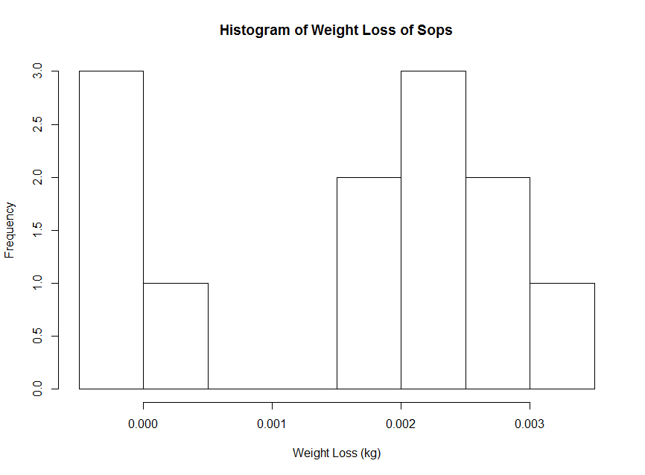

5. The boxplot is shown below:

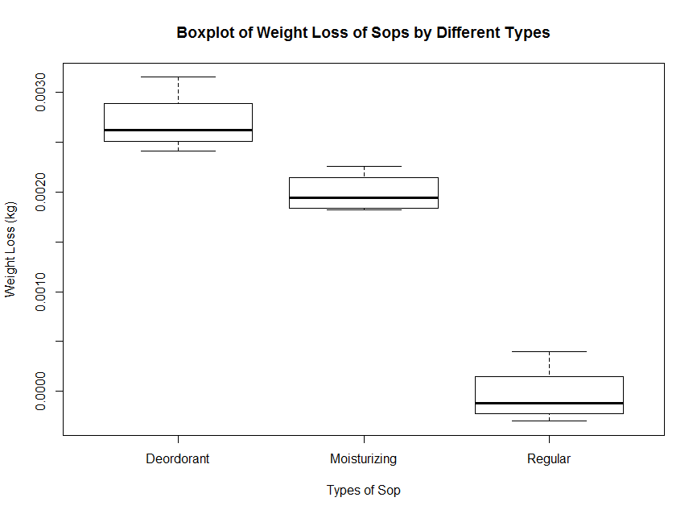

­

6.

By onserving the boxplot and the histogram, we can see that both the “Deordorant” and the “Moisturizing” types of sops dissolve and loss some weight. For some of the “Regular” type of sop, only one sop losses a very small amount of weight; on the other hand, 3 sops even gain weight. Thus, the “Regular” type of sop should be worthy to investigate further because we do not know whether the “Regular” sop dissolve effectively when it is being used.

Note: the next page gives the R code used for analyzing the data.

R code:

type=c(rep("Regular",4),rep("Deordorant",4),rep("Moisturizing",4))

cube=1:12

weightloss=c(-0.30,-0.10,-0.14,0.40,2.63,2.61,2.41,3.15,1.86,2.03,2.26,1.82)

experiment=data.frame(type,weightloss)

experiment

weightloss.kg=weightloss/1000

weightloss.kg

experiment.kg=data.frame(cube,type,weightloss.kg)

experiment.kg

mean(weightloss.kg)

mean(weightloss.kg[type=="Regular"])

mean(weightloss.kg[type=="Deordorant"])

mean(weightloss.kg[type=="Moisturizing"])

sd(weightloss.kg)

sd(weightloss.kg[type=="Regular"])

sd(weightloss.kg[type=="Deordorant"])

sd(weightloss.kg[type=="Moisturizing"])

hist(weightloss.kg,main="Histogram of Weight Loss of Sops",

xlab="Weight Loss (kg)")

boxplot(weightloss.kg~type, data=experiment.kg,

main="Boxplot of Weight Loss of Sops by Different Types",

ylab="Weight Loss (kg)", xlab="Types of Sop")

After Running the R code:

> type=c(rep("Regular",4),rep("Deordorant",4),rep("Moisturizing",4))

> cube=1:12

> weightloss=c(-0.30,-0.10,-0.14,0.40,2.63,2.61,2.41,3.15,1.86,2.03,2.26,1.82)

>

> experiment=data.frame(type,weightloss)

> experiment

type weightloss

1 Regular -0.30

2 Regular -0.10

3 Regular -0.14

4 Regular 0.40

5 Deordorant 2.63

6 Deordorant 2.61

7 Deordorant 2.41

8 Deordorant 3.15

9 Moisturizing 1.86

10 Moisturizing 2.03

11 Moisturizing 2.26

12 Moisturizing 1.82

>

> weightloss.kg=weightloss/1000

> weightloss.kg

[1] -0.00030 -0.00010 -0.00014 0.00040 0.00263 0.00261 0.00241 0.00315 0.00186 0.00203 0.00226 0.00182

>

> experiment.kg=data.frame(cube,type,weightloss.kg)

> experiment.kg

cube type weightloss.kg

1 1 Regular -0.00030

2 2 Regular -0.00010

3 3 Regular -0.00014

4 4 Regular 0.00040

5 5 Deordorant 0.00263

6 6 Deordorant 0.00261

7 7 Deordorant 0.00241

8 8 Deordorant 0.00315

9 9 Moisturizing 0.00186

10 10 Moisturizing 0.00203

11 11 Moisturizing 0.00226

12 12 Moisturizing 0.00182

>

> mean(weightloss.kg)

[1] 0.0015525

> mean(weightloss.kg[type=="Regular"])

[1] -3.5e-05

> mean(weightloss.kg[type=="Deordorant"])

[1] 0.0027

> mean(weightloss.kg[type=="Moisturizing"])

[1] 0.0019925

>

> sd(weightloss.kg)

[1] 0.00123644

> sd(weightloss.kg[type=="Regular"])

[1] 0.0003025998

> sd(weightloss.kg[type=="Deordorant"])

[1] 0.0003160169

> sd(weightloss.kg[type=="Moisturizing"])

[1] 0.000200229

>

> hist(weightloss.kg,main="Histogram of Weight Loss of Sops",

+ xlab="Weight Loss (kg)")

>

> boxplot(weightloss.kg~type, data=experiment.kg,

+ main="Boxplot of Weight Loss of Sops by Different Types",

+ ylab="Weight Loss (kg)", xlab="Types of Sop")